Batch: B2 Roll No.: 1611103

Experiment / assignment / tutorial No._______

Grade: AA / AB / BB / BC / CC / CD /DD

Signature of the Staff In-charge with date

TITLE :Implementation of FIFO Page Replacement Algorithm

AIM: The FIFO algorithm uses the principle that the block in the set which has been in for the longest time will be replaced
______________________________________________________________________
Expected OUTCOME of Experiment:
CO 4-Learn and evaluate memory organization and cache structure
_____________________________________________________________________
Books/ Journals/ Websites referred:
- Carl Hamacher, Zvonko Vranesic and Safwat Zaky, “Computer Organization”, Fifth Edition, TataMcGraw-Hill.
- William Stallings, “Computer Organization and Architecture: Designing for Performance”, Eighth Edition, Pearson.
3. Dr. M. Usha, T. S. Srikanth, “Computer System Architecture and Organization”, First Edition, Wiley-India.
---------------------------------------------------------------------------------------------------------
Pre Lab/ Prior Concepts:

T he FIFO algorithm uses the principle that the block in the set which has been in the block for the longest time is replaced. FIFO is easily implemented as a round robin or criteria buffer technique. The data structure used for implementation is a queue. Assume that the number of cache pages is three. Let the request to this cache is shown alongside.

Algorithm:

1. A hit is said to be occurred when a memory location requested is already in the cache.
2. When cache is not full, the number of blocks is added.
3. When cache is full, the block is replaced which was added first

Design Steps:

- Start
- Get input as memory block to be added to cache
- Consider an element of the array
- If cache is not full, add element to the cache array
- If cache is full, check if element is already present
- If it is hit is incremented
- If not, element is added to cache removing first element (which is in first).
- Repeat step 3 to 7 for remaining elements
- Display the cache at very instance of step 8
- Print hit ratio
- End.

Example:

#include<stdio.h>
//#include<conio.h>
#define WINDOW 2

int check(int a[],int r,int ele)
{
for(int i = 0;i<=r;i++)
{
if(a[i] == ele)
return i; //to HIT
}
if(r == WINDOW)
return 4; //delete last used element and insert new.
else if(r<WINDOW)
return 5; //to just insert
}

int main()
{
int in,page[WINDOW+1],rp = -1,FI;
label:
printf("Enter element to insert (-1 to Quit) : \n");
scanf("%d",&in);
if(in != -1){
switch( check(page,rp,in) )
{
case 5: page[++rp] = in;
break;
case 4: printf("%d is the first element to enter.Deleting and inserting new : \n",FI);
for(int i =0;i<WINDOW;i++)
{
page[i] = page[i+1];
}
page[rp] = in ;
break;
default: printf(“Hit!!!\n”);
break;
}
FI = page[0];
printf("The cache is : \n");
for(int i = 0;i<=rp;i++)
{
printf("%d ",page[i]);
}
printf("\nFirst Entered Element : %d\n",FI);
goto label;
}
return 0;
}

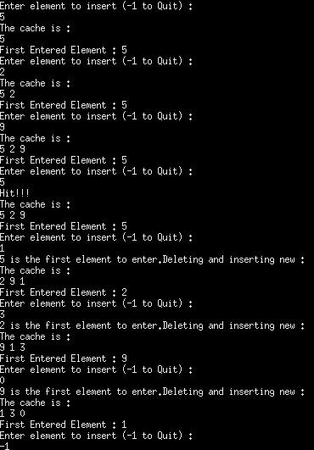

Post Lab Descriptive Questions (Add questions from examination point view)

1. What is meant by memory interleaving?
Ans. In computing, interleaved memory is a design made to compensate for the relatively slow speed of dynamic random-access memory (DRAM) or core memory, by spreading memory addresses evenly across memory banks. That way, contiguous memory reads and writes are using each memory bank in turn, resulting in higher memory throughputs due to reduced waiting for memory banks to become ready for desired operations.
With interleaved memory, memory addresses are allocated to each memory bank in turn. For example, in an interleaved system with two memory banks (assuming word-addressable memory), if logical address 32 belongs to bank 0, then logical address 33 would belong to bank 1, logical address 34 would belong to bank 0, and so on. An interleaved memory is said to be n-way interleaved when there are n banks and memory location i resides in bank i mod n.Interleaved memory results in contiguous reads (which are common both in multimedia and execution of programs) and contiguous writes (which are used frequently when filling storage or communication buffers) actually using each memory bank in turn, instead of using the same one repeatedly. This results in significantly higher memory throughput as each bank has a minimum waiting time between reads and writes.

2. Explain Paging Concept?
Ans. In computer operating systems, paging is a memory management scheme by which a computer stores and retrieves data from secondary storage for use in main memory. In this scheme, the operating system retrieves data from secondary storage in same-size blocks called pages. Paging is an important part of virtual memory implementations in modern operating systems, using secondary storage to let programs exceed the size of available physical memory. Here the main memory is referes to RAM and secondary storage to Hard disk.

Conclusion
Hence the FIFO page replacement policy is studied and implemented in C++.

Date: _____________ Signature of faculty in-charge

